**Tour-Planner Website**

**Project Report**

**Submitted by:**

**Isha Sethia(21209)**

**In partial fulfillment for the award of degree**

**Of**

**M.sc**

**In**

**Computer Science**

**At**



**Department of Computer Science**

**Maharaja Ganga Singh University, Bikaner**

**NH-15, Jaisalmer Road, Rajasthan (India) - 334001**

**Month & Year**

**2022**

**DECLARATION**

We hereby declare that the project entitled “Tour-Planner Website” submitted for the M.sc Computer Science degree is our original work and the project has not formed the basis for the award of any other degree, diploma, fellowship or any other similar titles.

**Signature of the Isha Sethia**

**Place:**

**Date:**

**CERTIFICATE**

This is to certify that the project titled “Tour-Planner Website” is the work carried out by Isha Sethia Student of M.sc Computer Science of Department of Computer Science, Maharaja Ganga Singh University, Bikaner, Rajasthan (India) during the academic year 2020-22, in partial fulfilment of the requirements for the award of the degree of M.sc Computer Science and that the project has not formed the basis for the award previously of any other degree, diploma, fellowship or any other similar title.

**Signature of the Guide**

**Place:**

**Date:**

**Table of Content**

* Introduction to Project
* System Requirement
* Source Code
* Home page(index.php)
* Categories page(category.php)
* Gallery page(gall.php)
* Login page(login.php)
* Contact-us page(contact.php)
* Search-Box page(show.php)
* Admin-page(nav.php)

**Introduction to Project**

We have a Tour-Planner website. You will find and explore Rajasthan here.” “Need to travel Rajasthan and want to know the exact budget? Welcome to our website where you can all about Rajasthan and also we provide you with our agents that would help you in your trip.” “We welcome you. Let our journey begin with us and satisfy your pocket.” Let us handle, and manage your entire trip ". “Welcome to our place. You will find happiness and adventure, everything.”

**System Requirement**

**Languages and tools used to build project**:

**Hardware Requirement:**

* AMD Sempron configuration
* Internet connection
* Minimum 1GB Ram
* Minimum 25 GB HDS

**Software Requirement:**

* **Operating system**: Window 7 Ultimate
* Editor : Sublime Text-3

**Front-End Languages:**

* HTML
* CSS
* JavaScript
* Xml
* JQuery

**Home Page (index.php)**

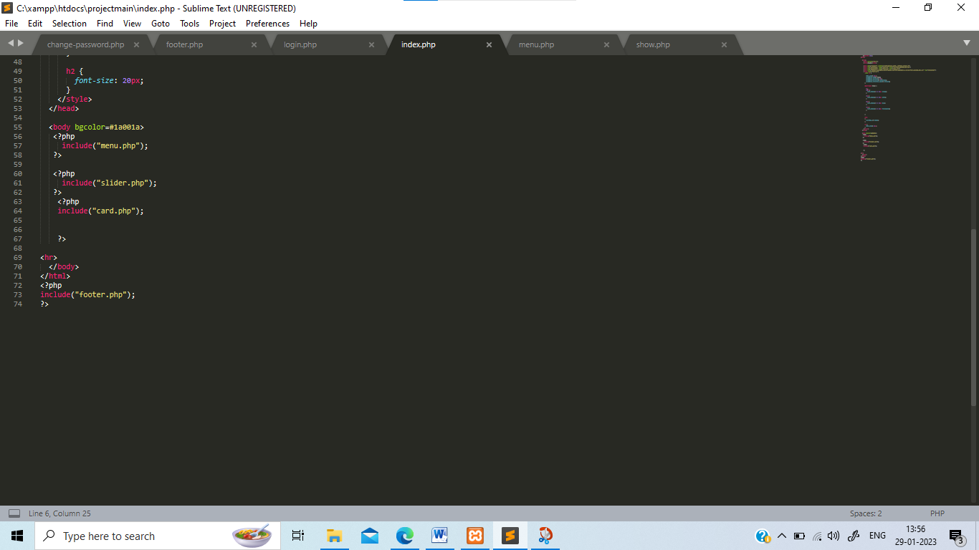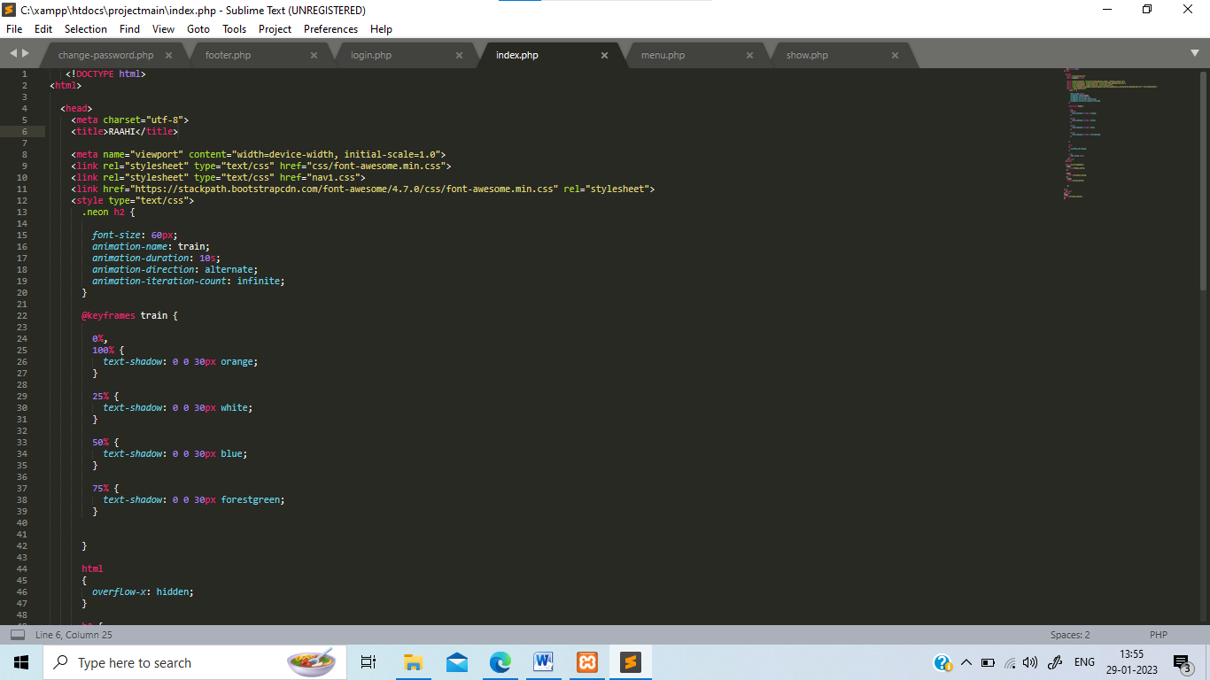

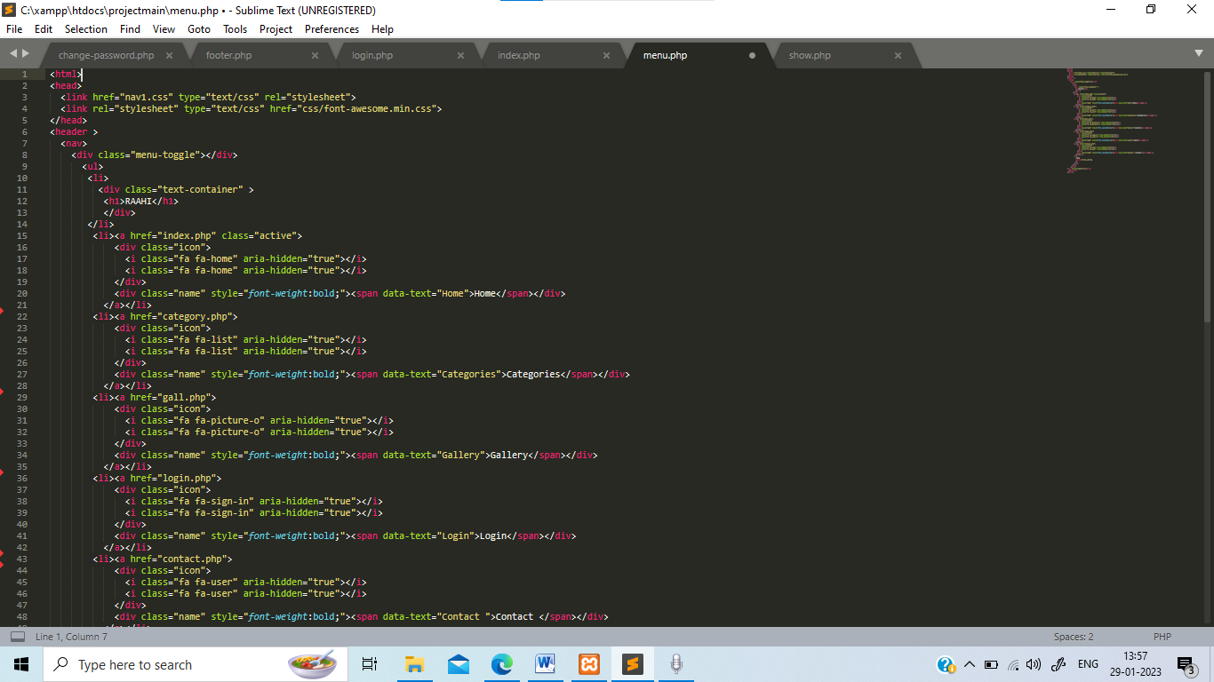menu.php

footer.php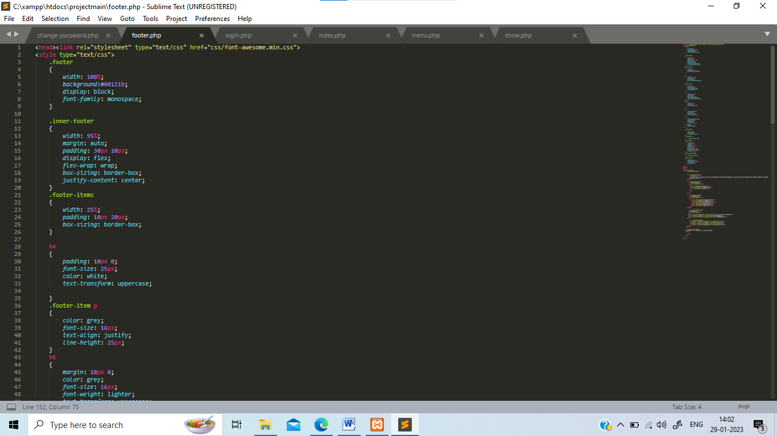

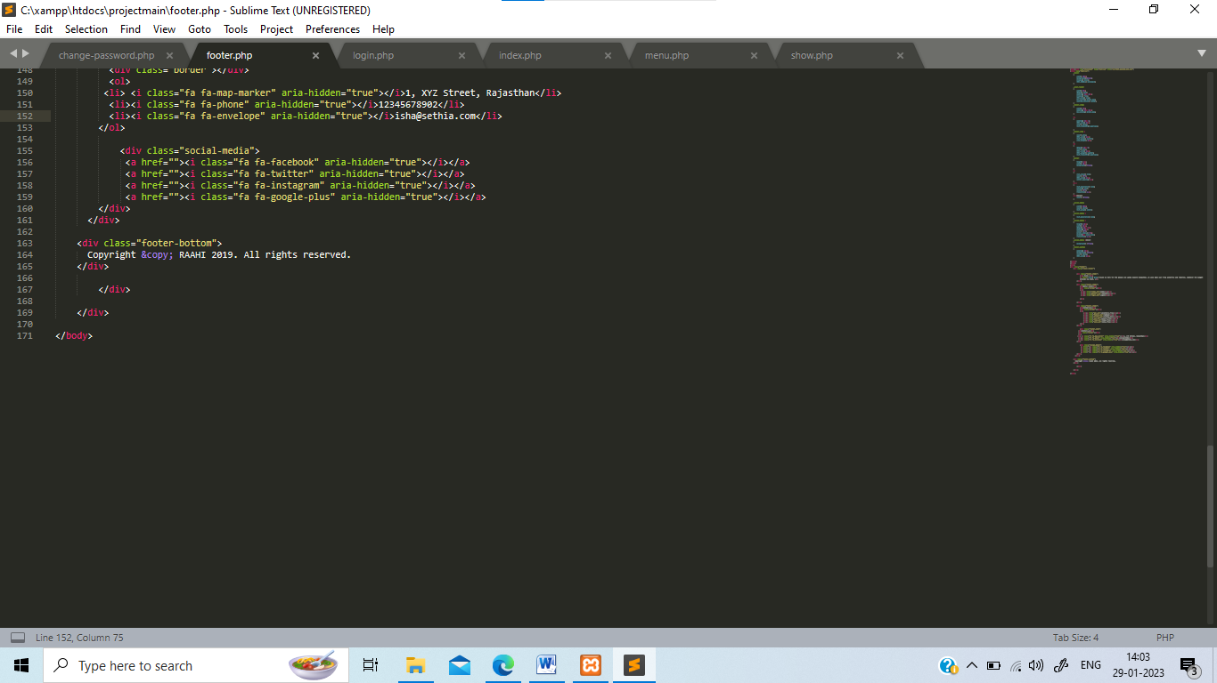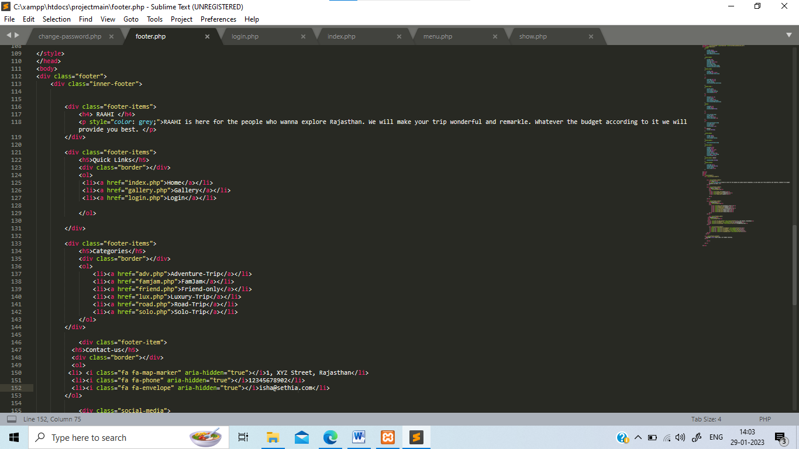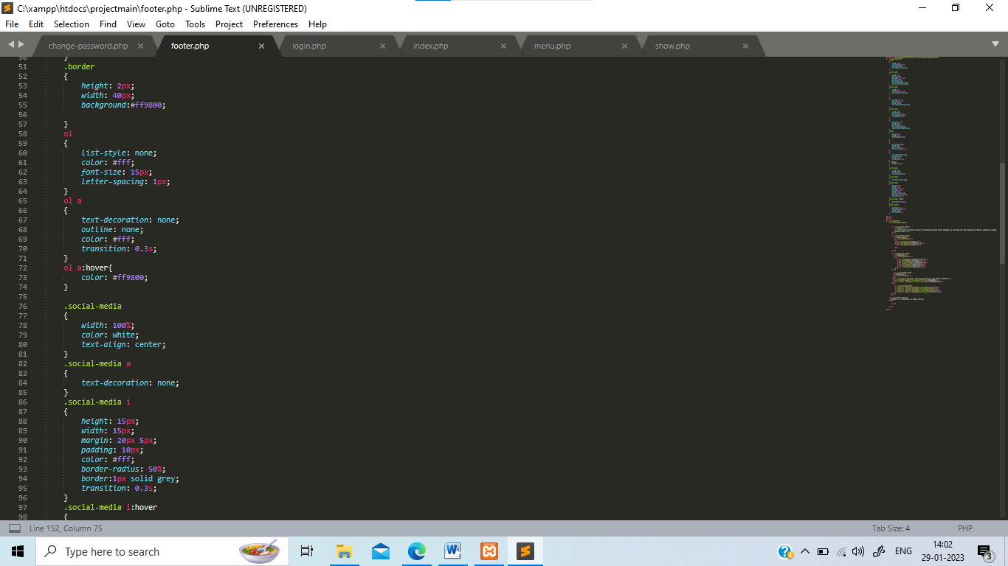

**Output:**

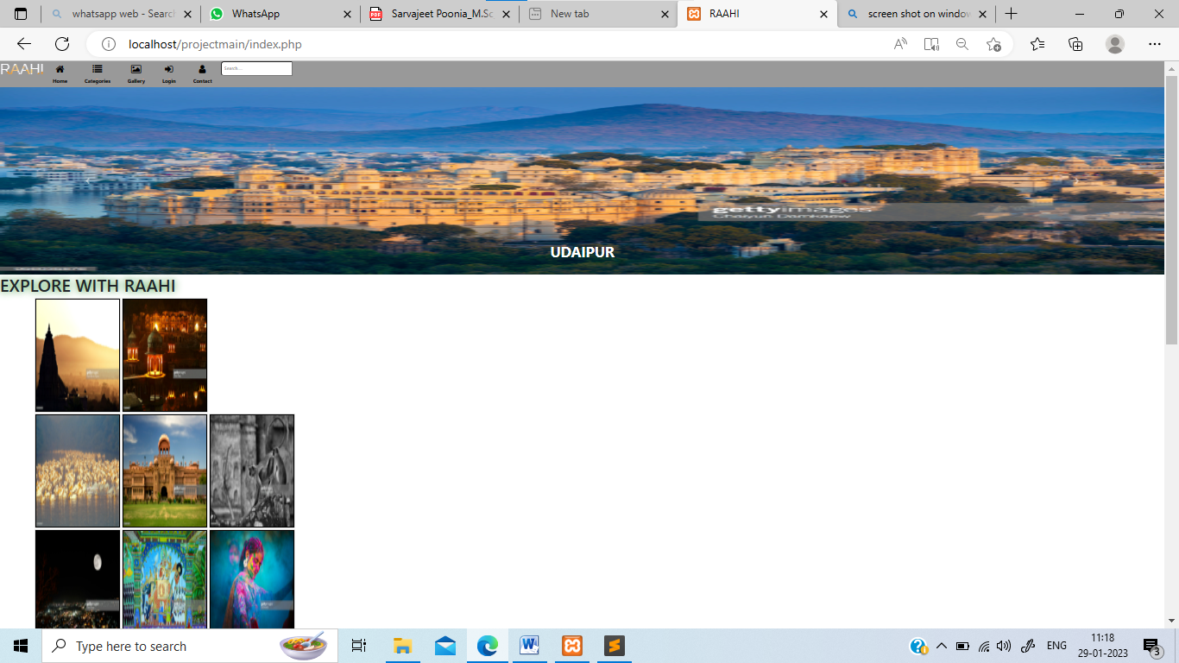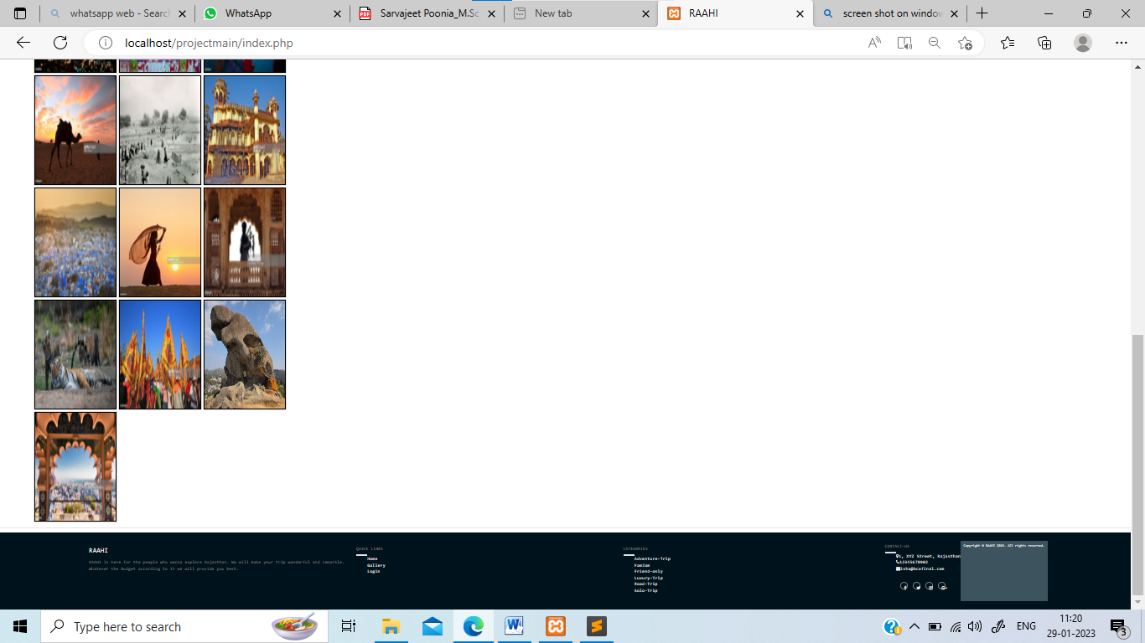

**Category Page(category.php)**

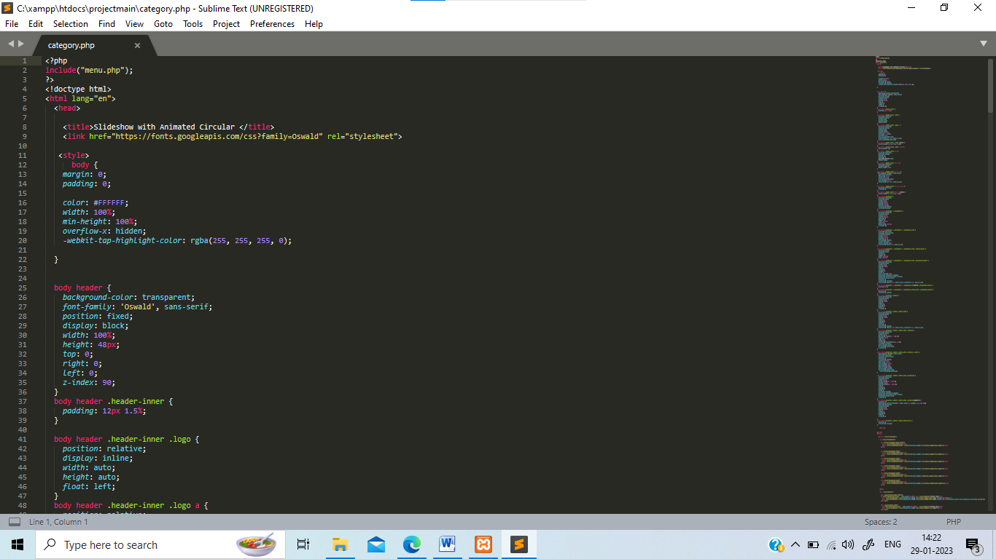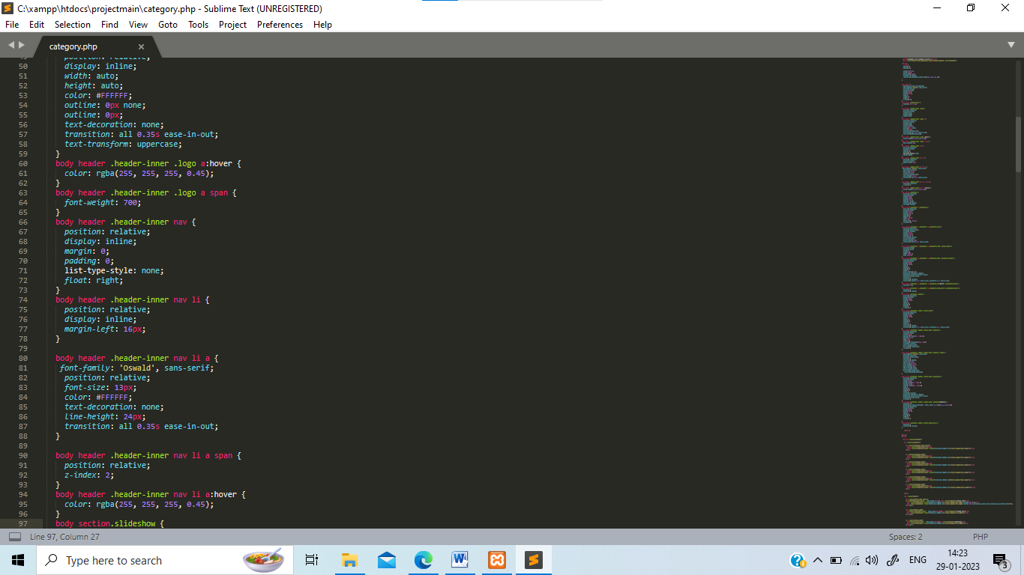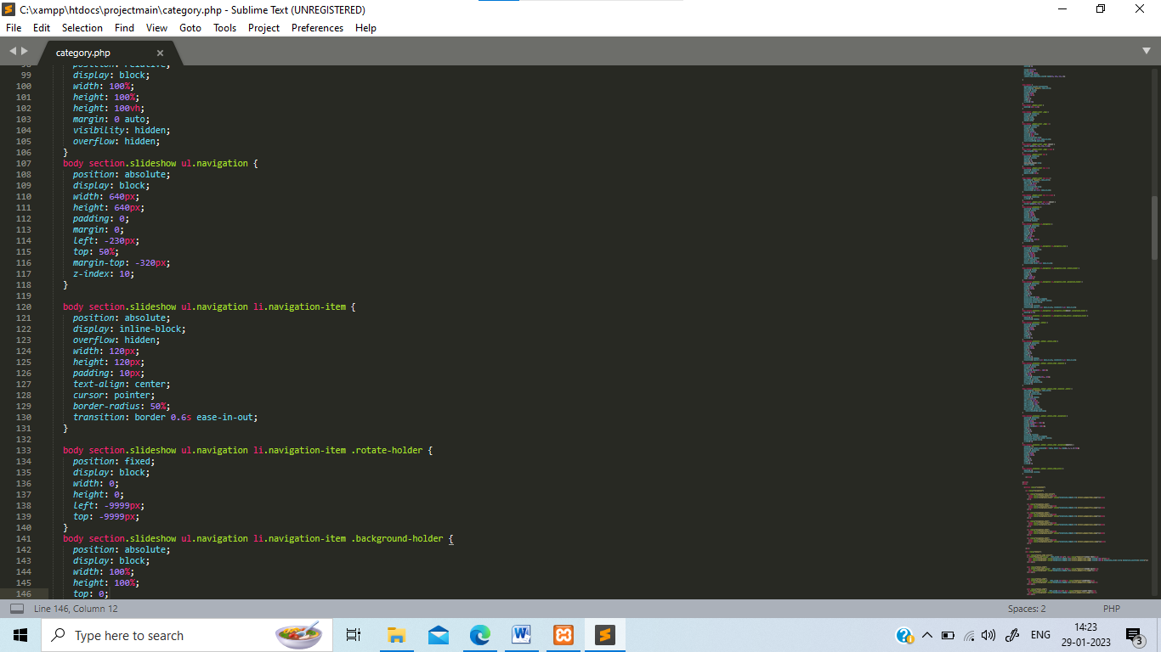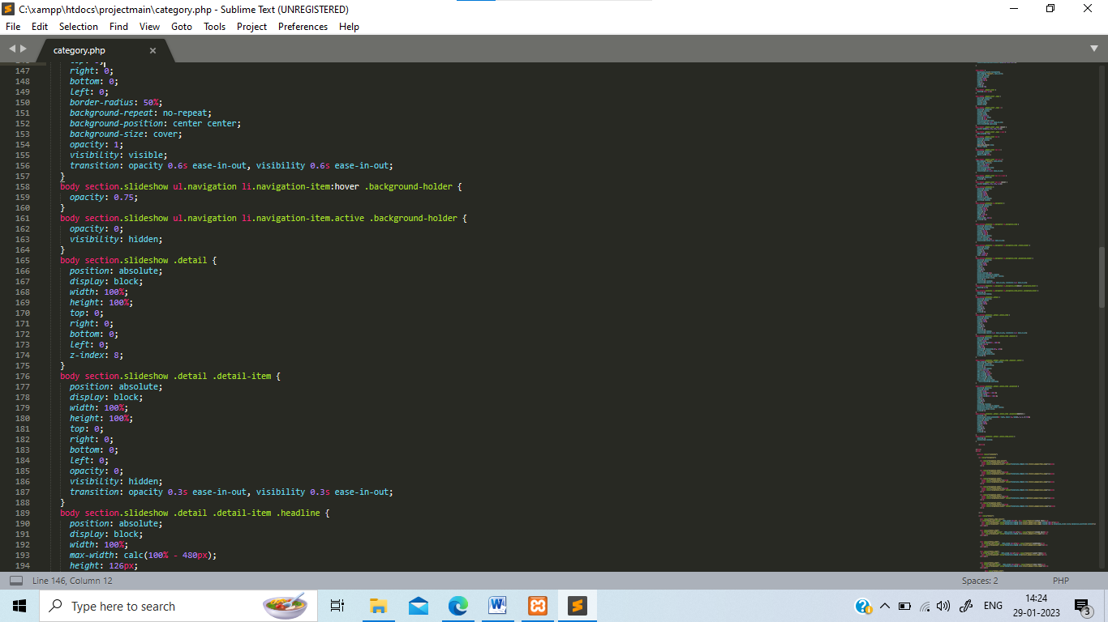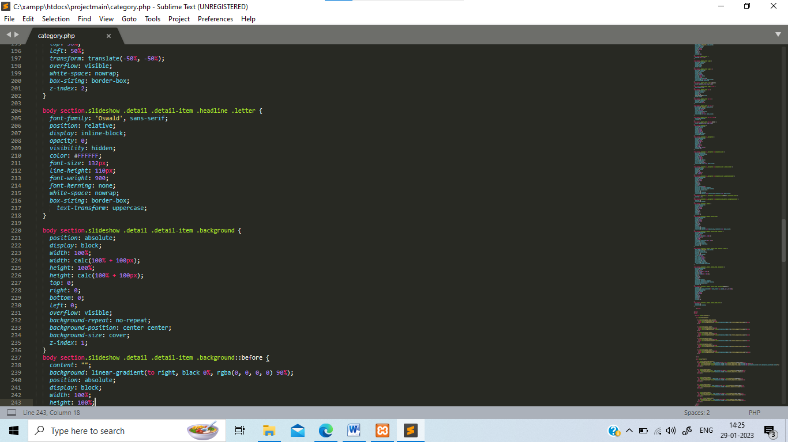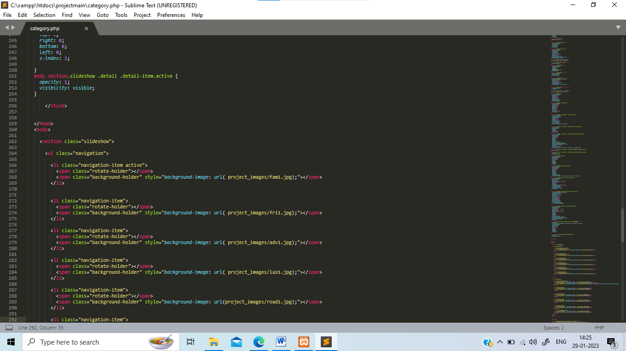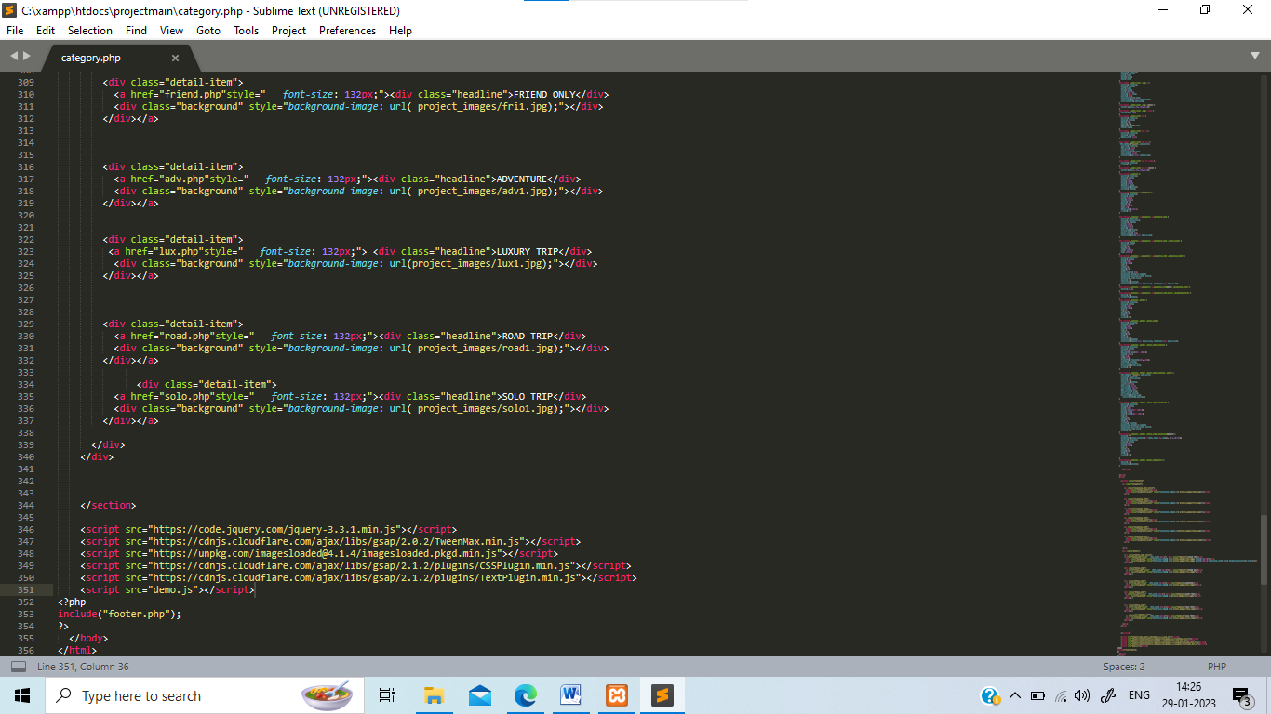

**Output:-**

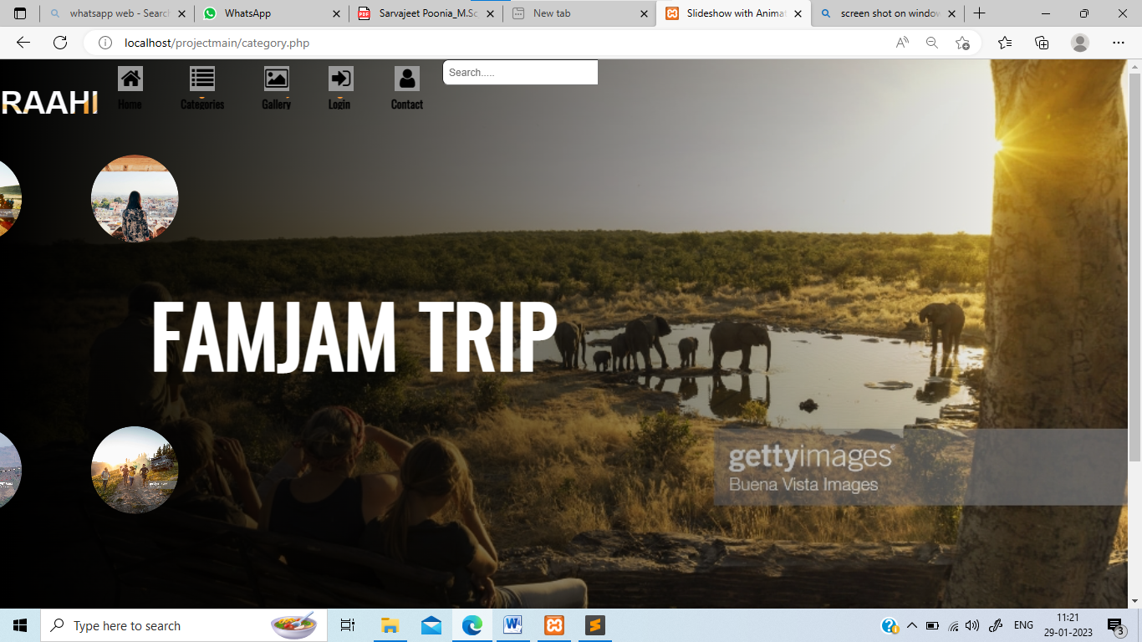

**Gallery page(gall.php)**

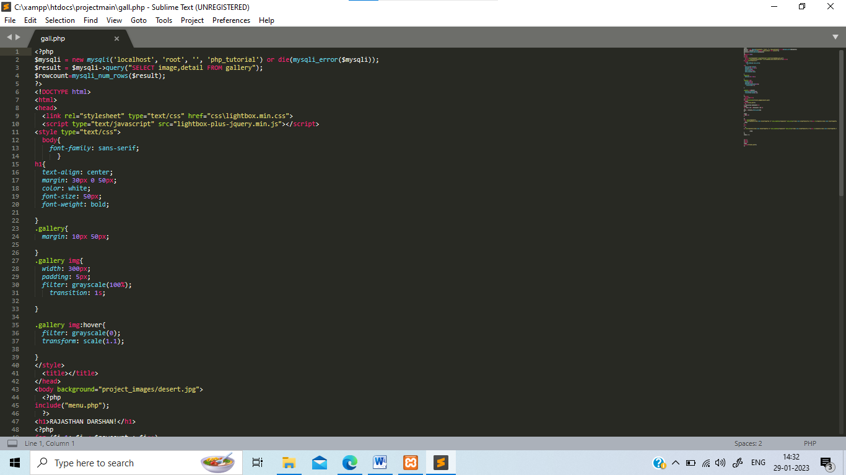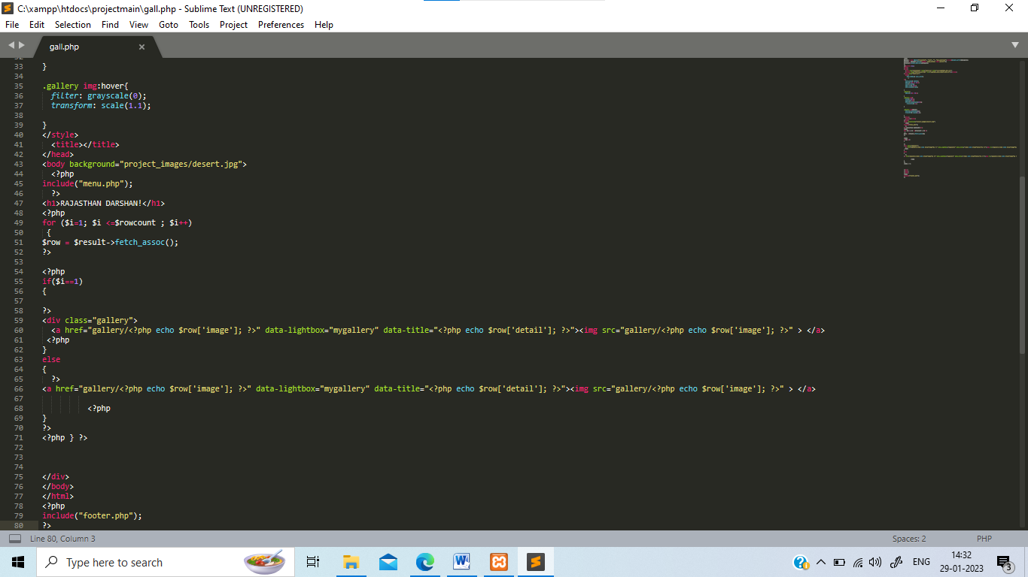

**Output:** 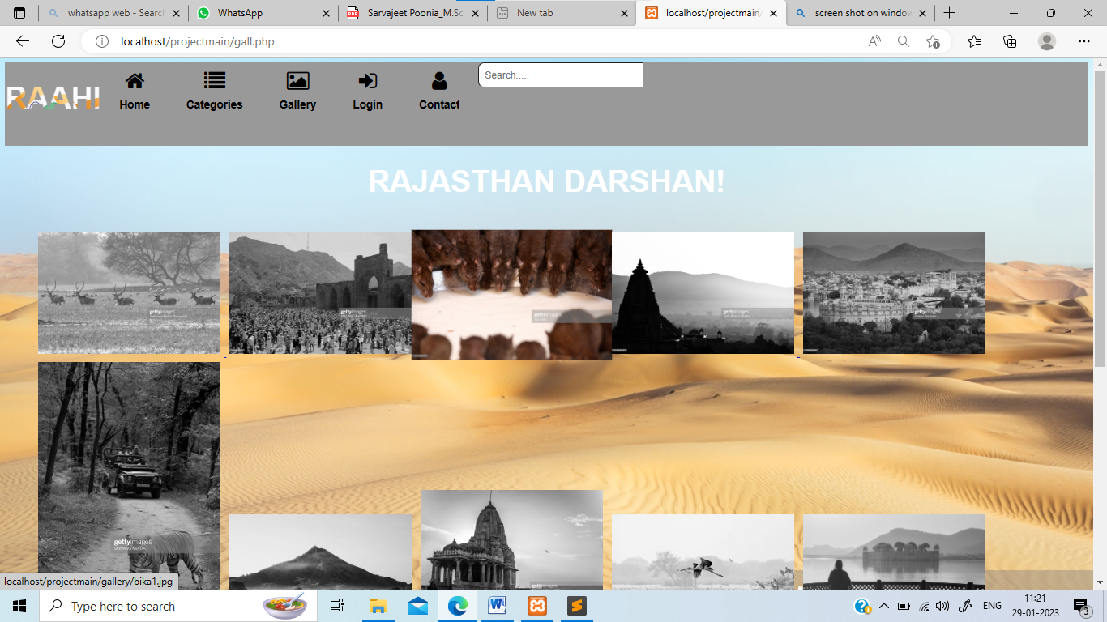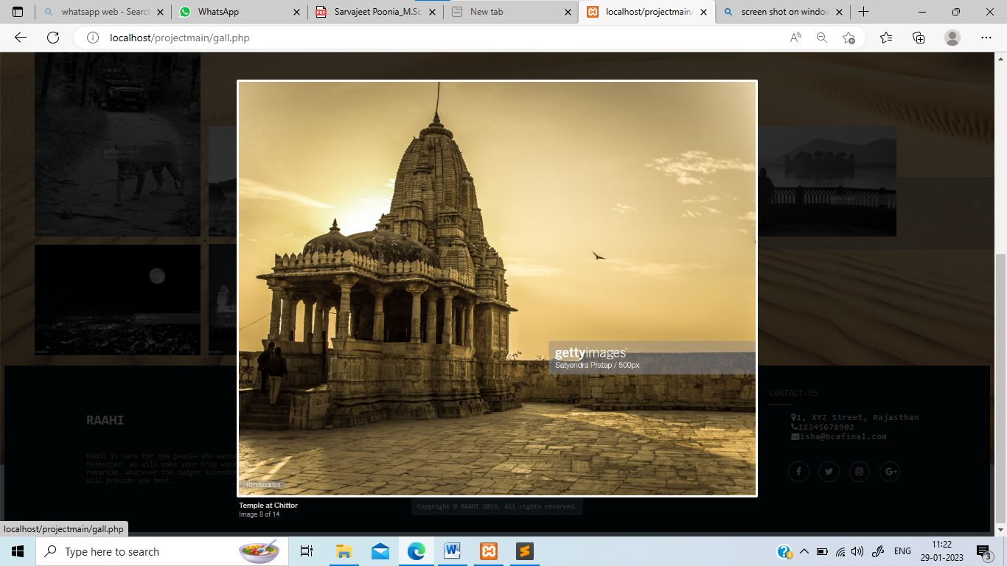 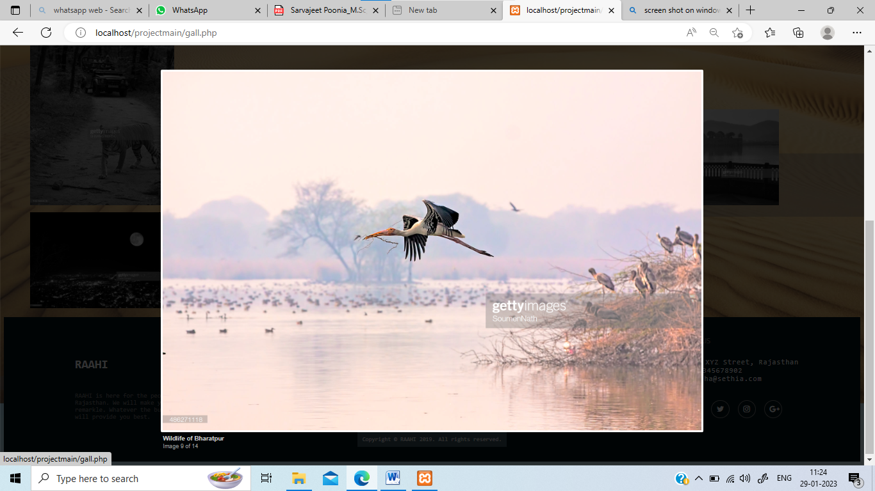

**Login Page(login.php)**

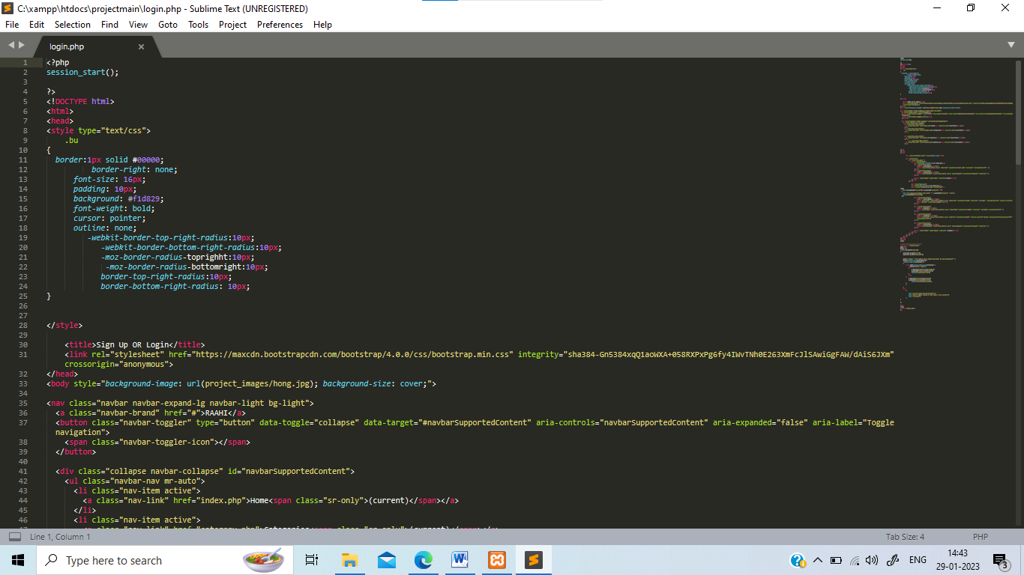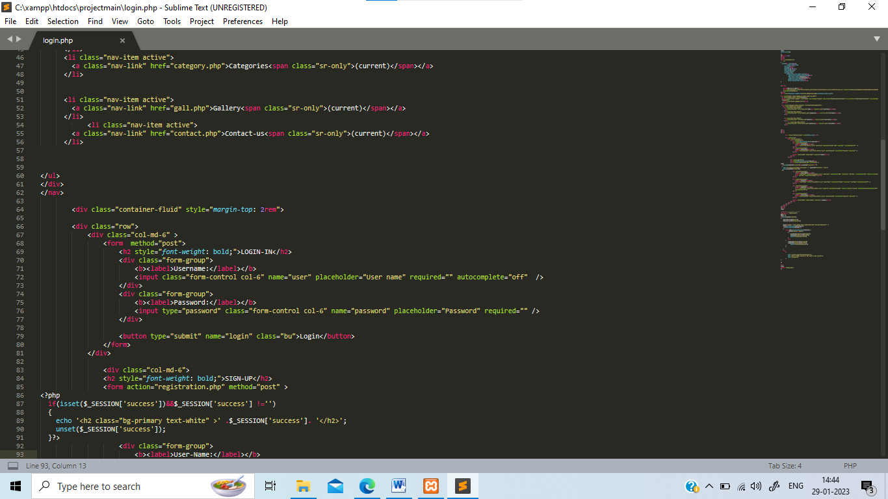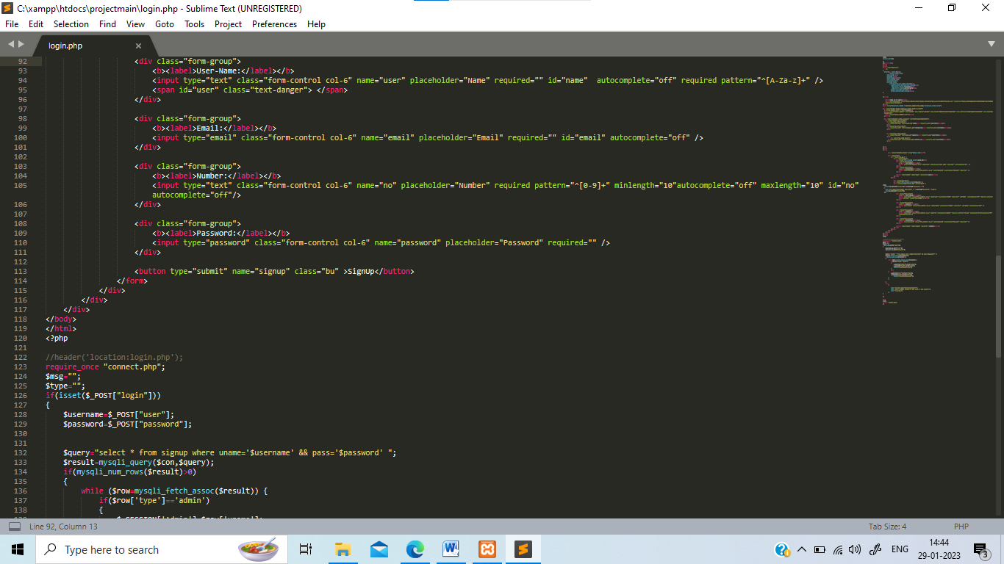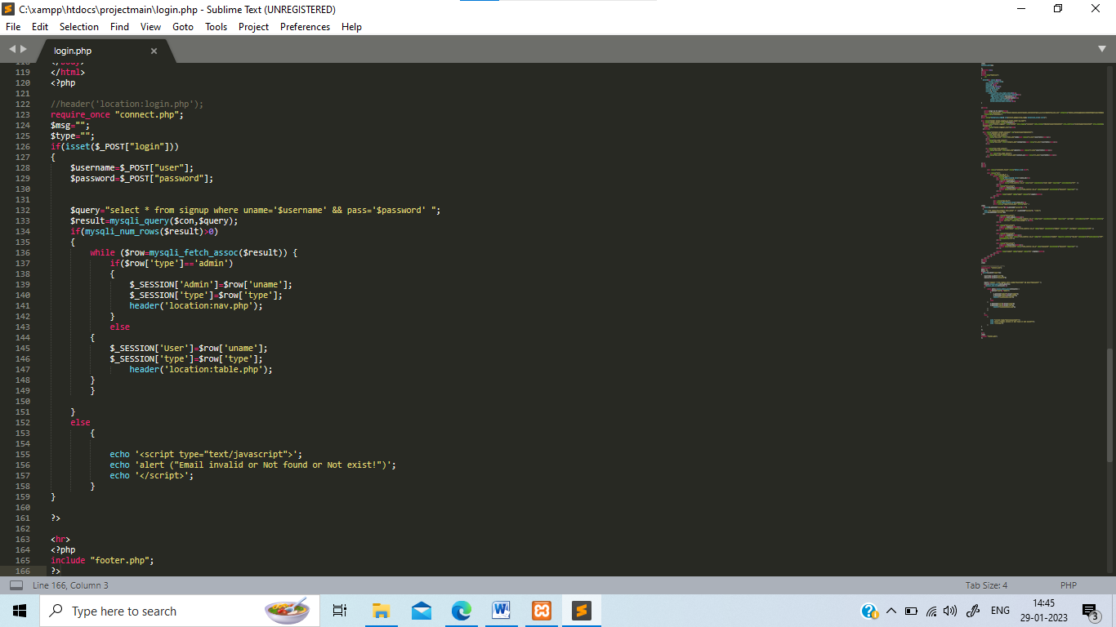

**Output:-**

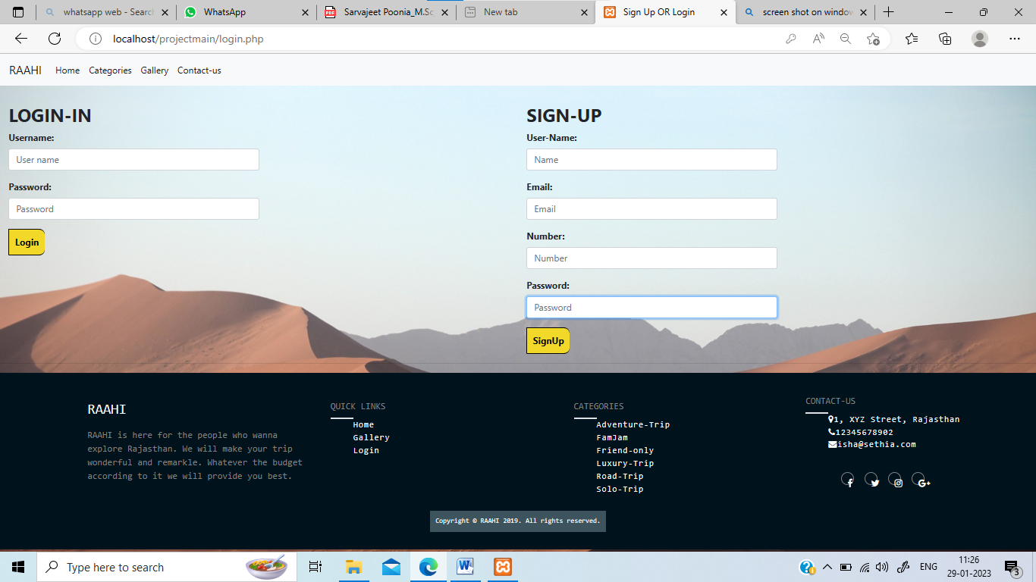

**Contact-us(contact.php):**

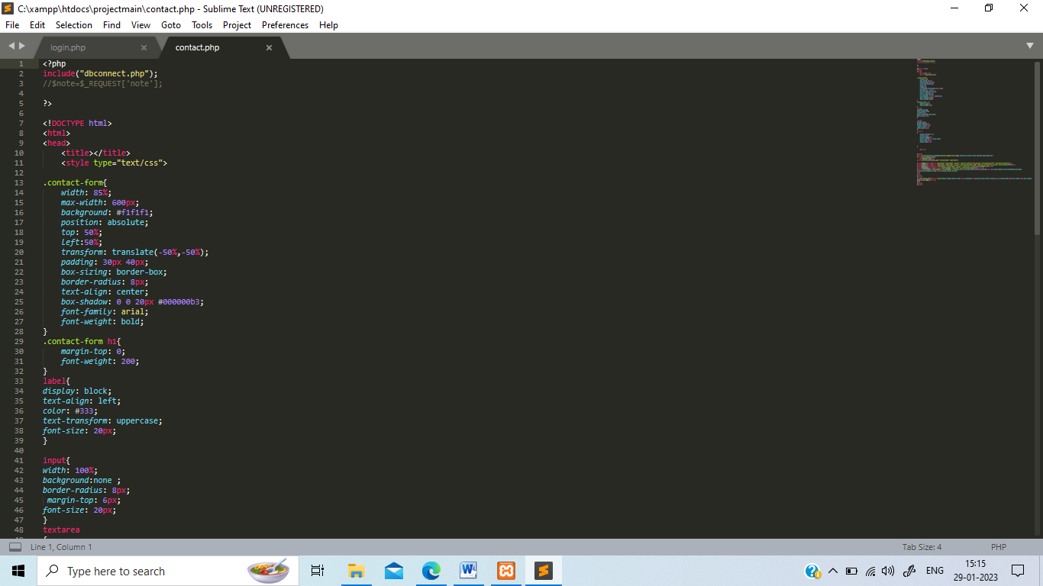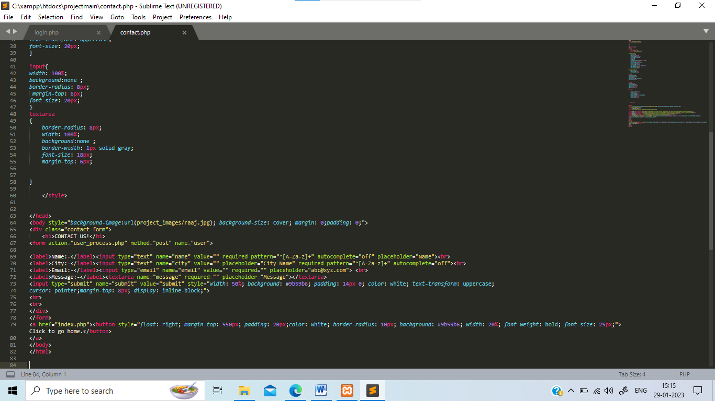

**Output:-**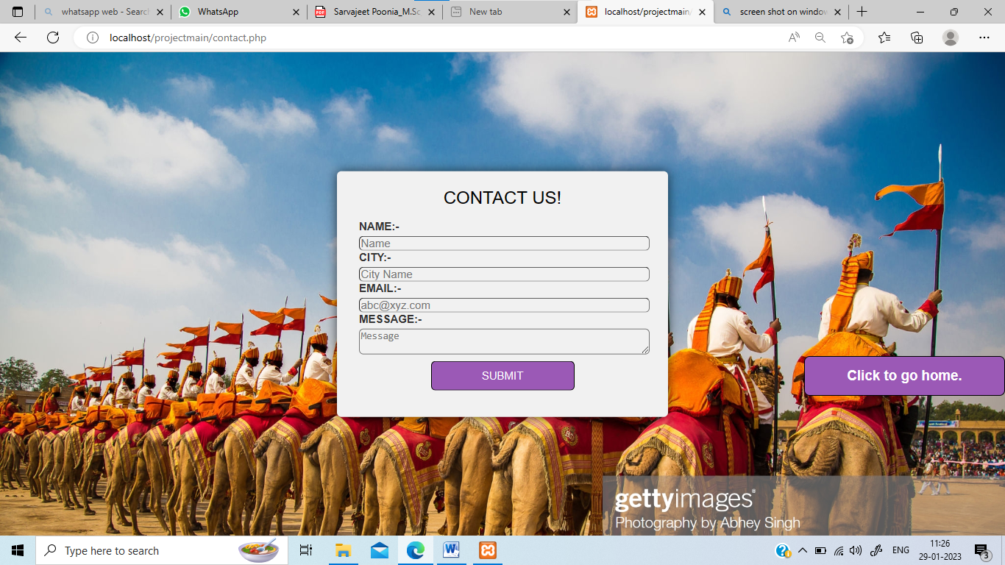

**Admin Panel(nav.php)**

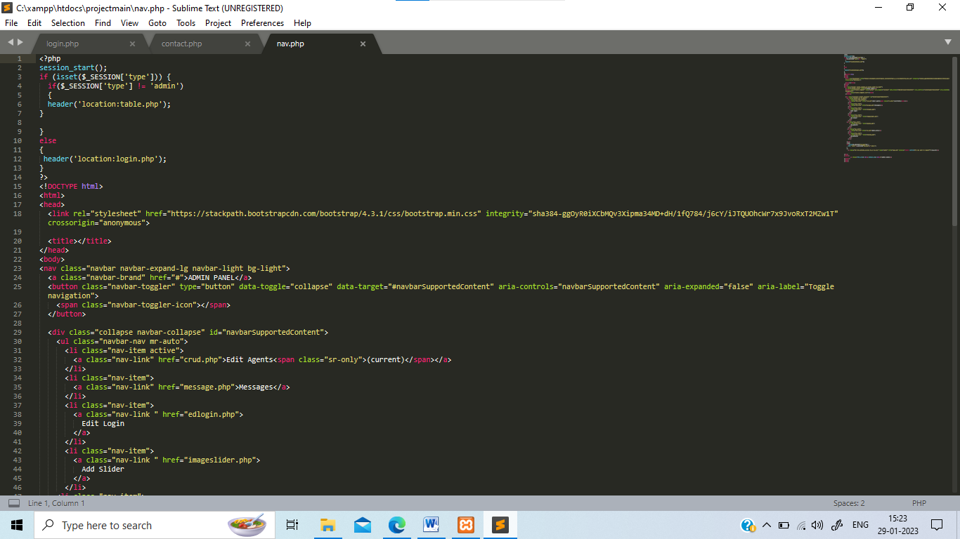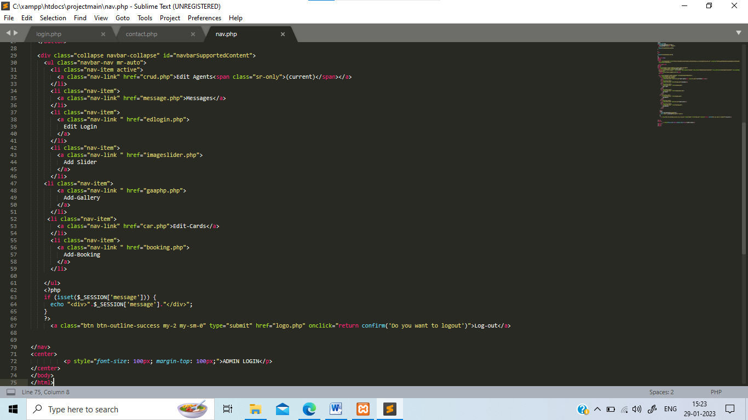**Output:**

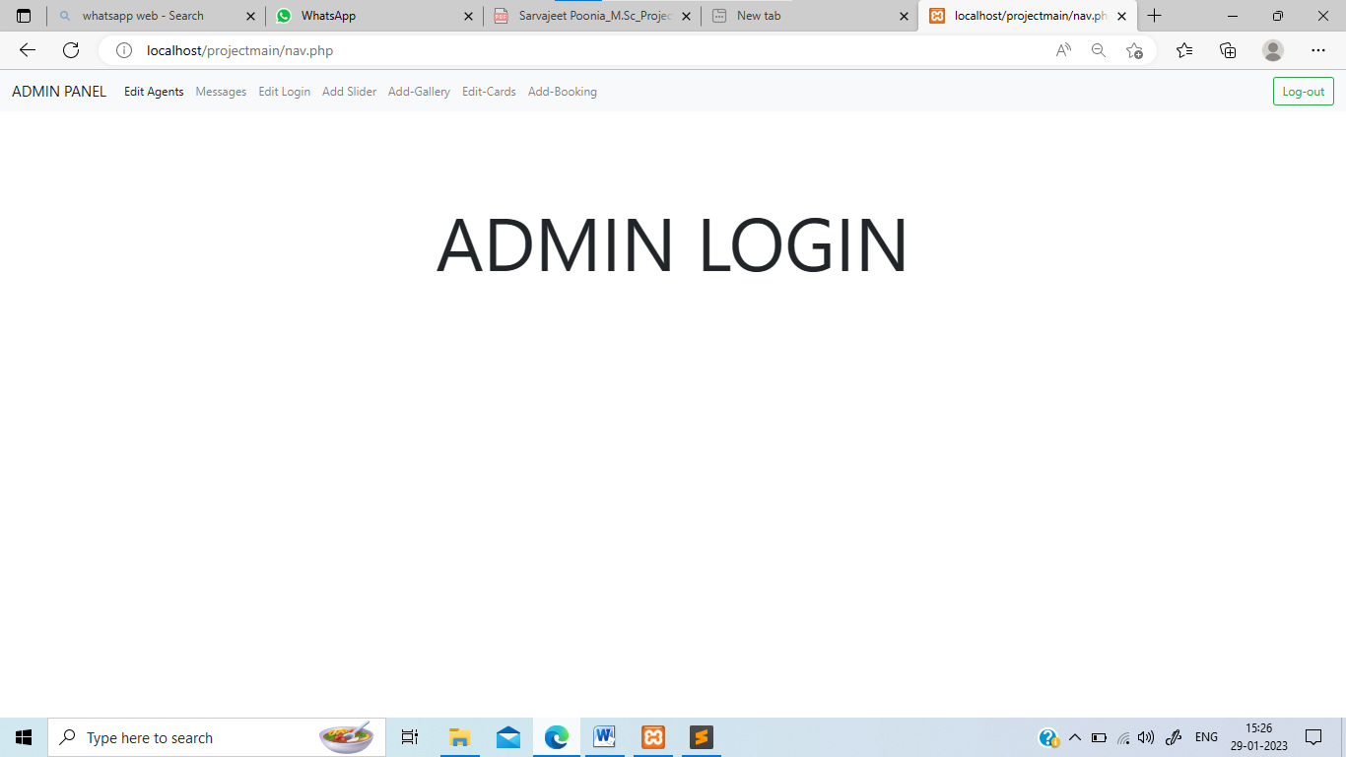

**Crud.php:**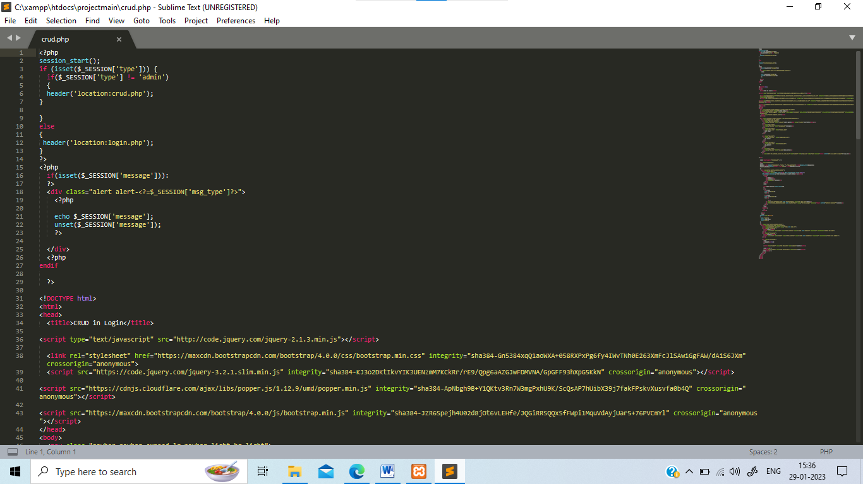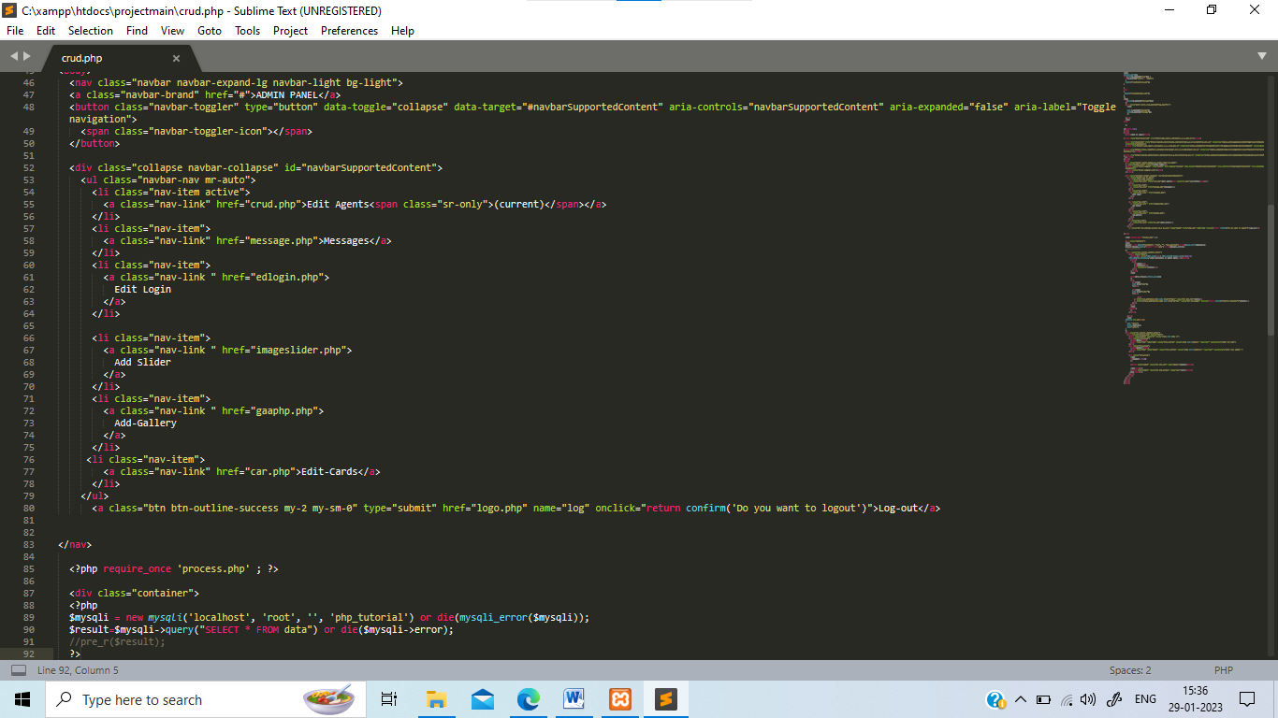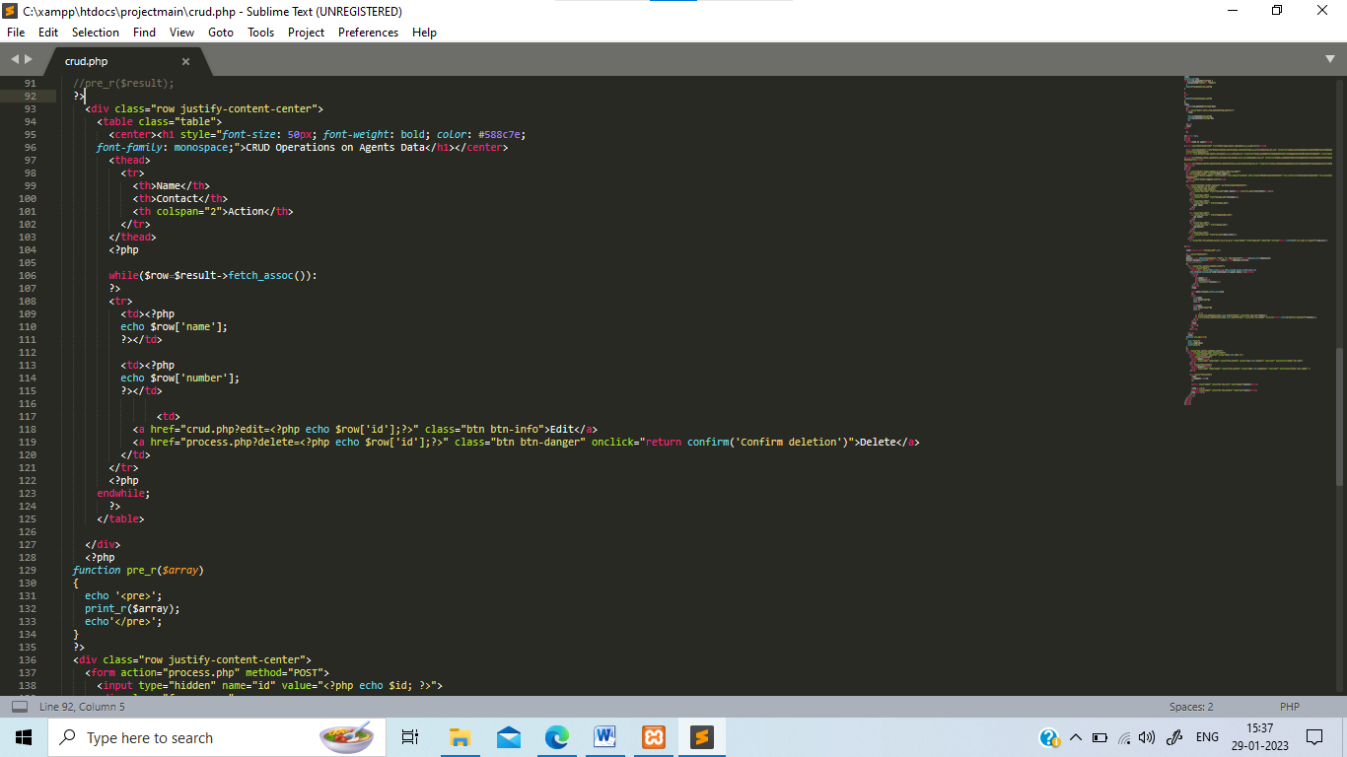

**Output:**

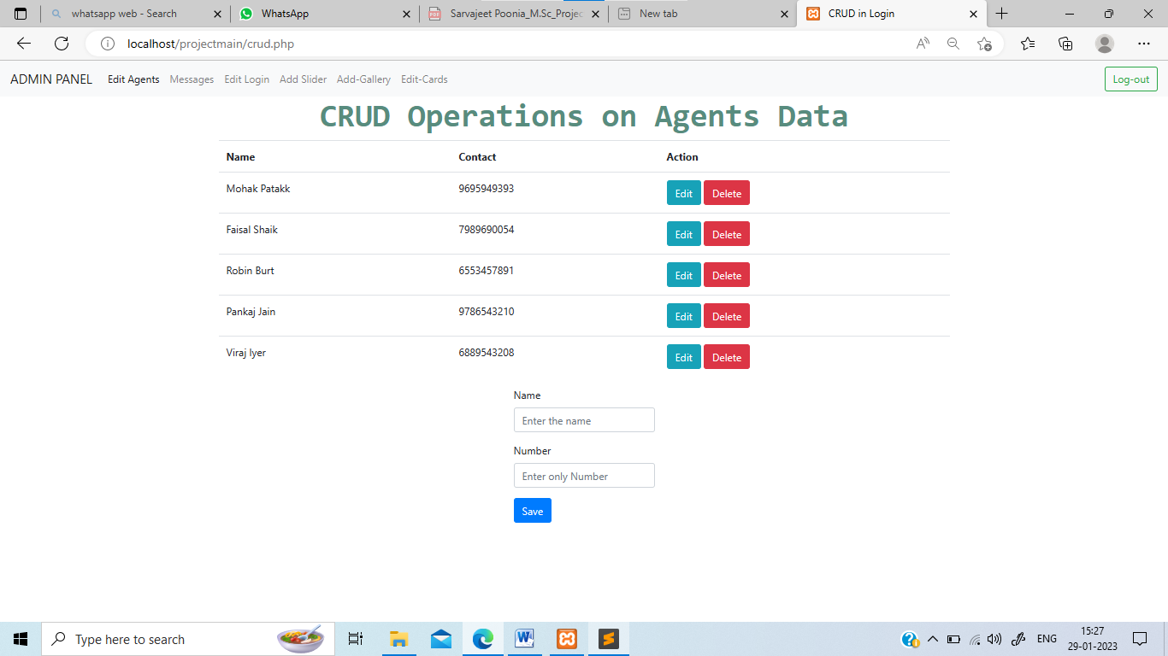**message.php**

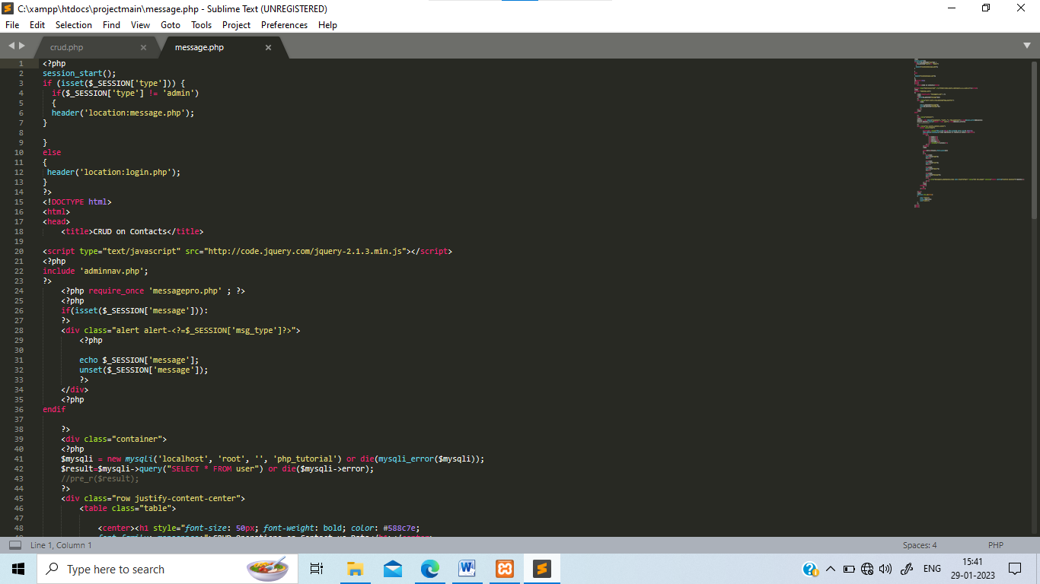

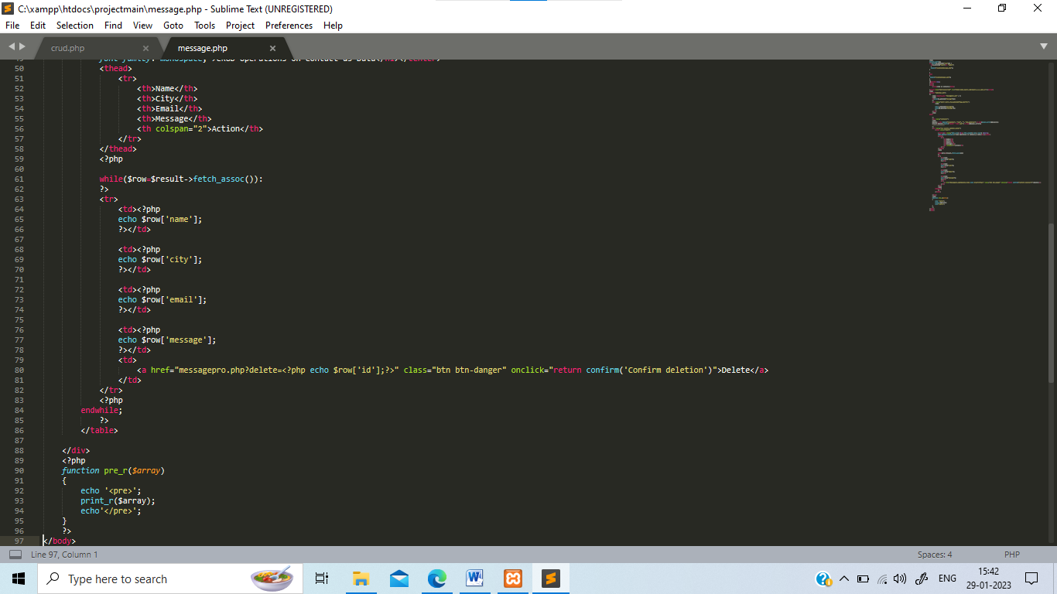

**Output:**

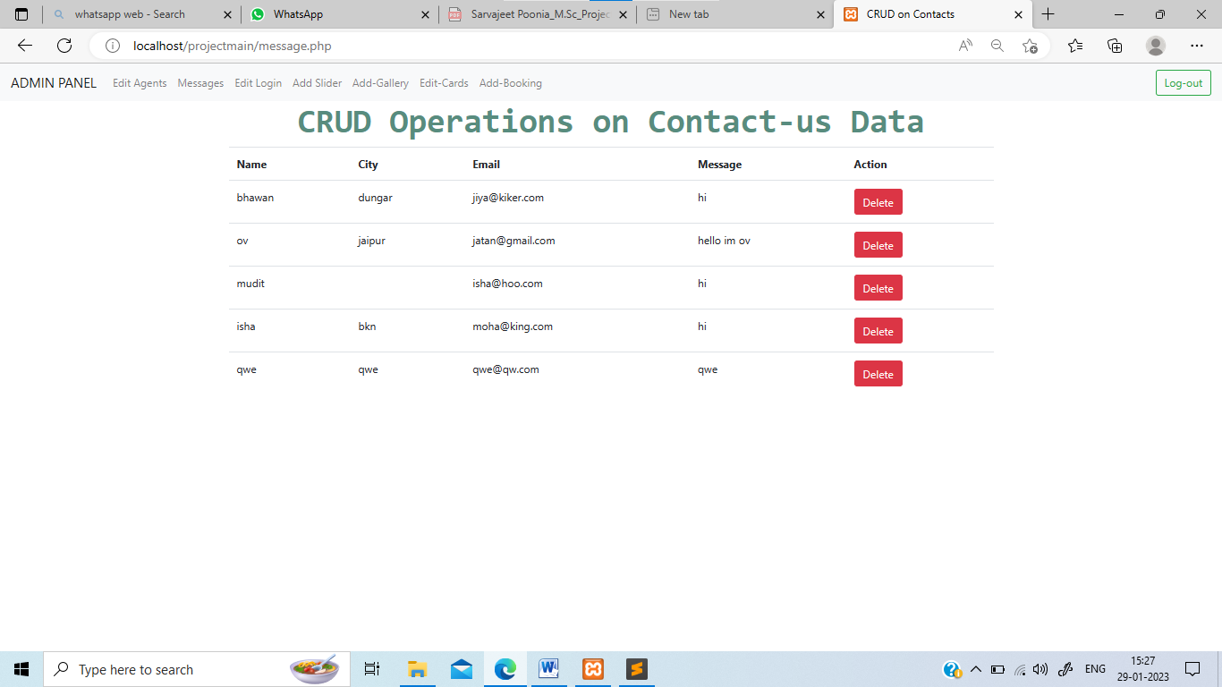

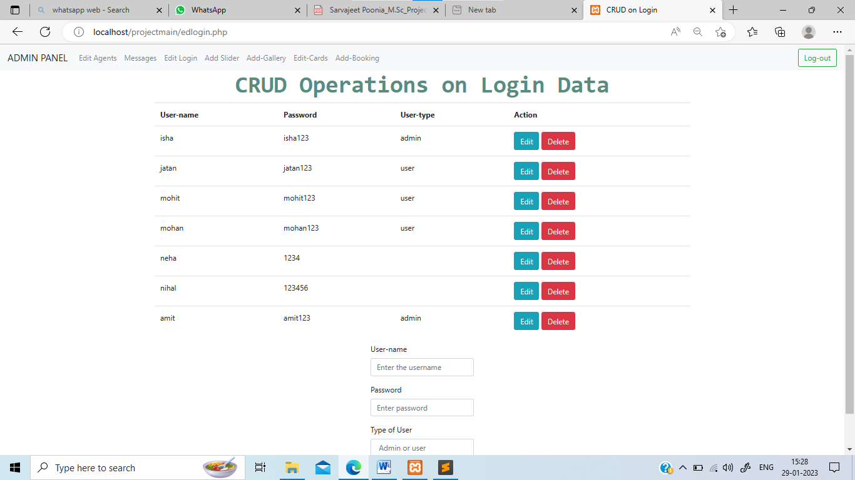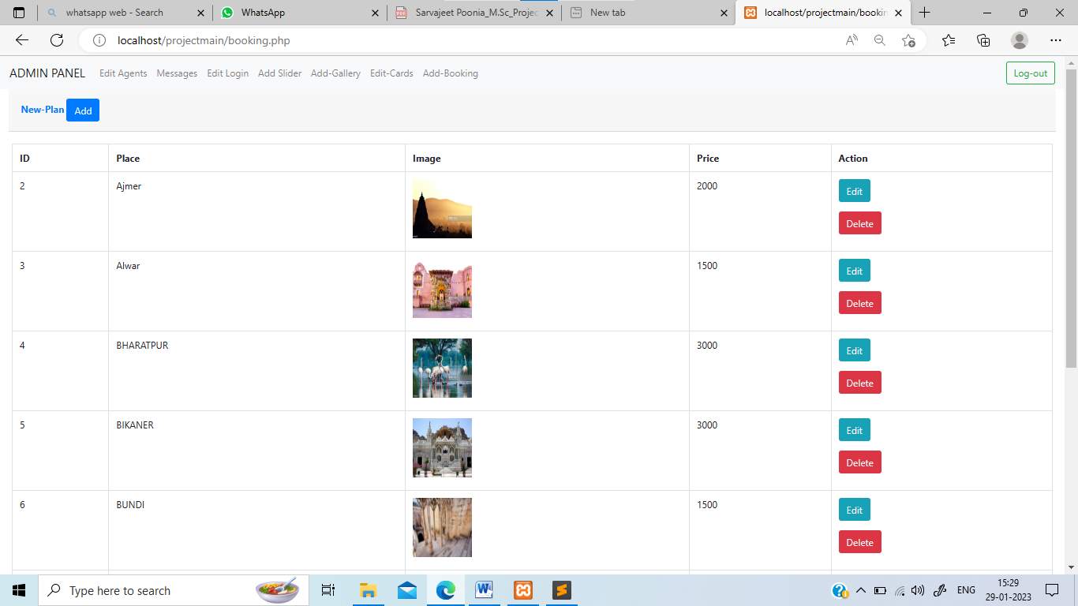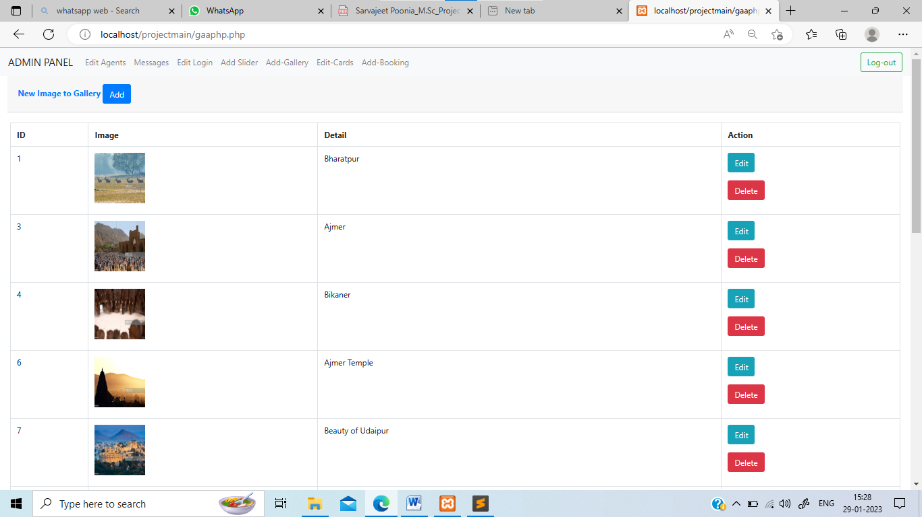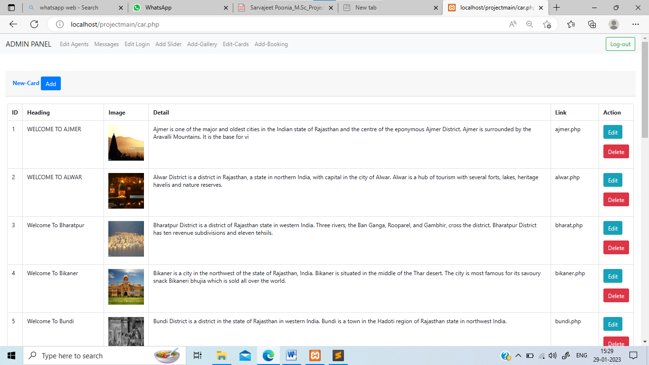

**Other Pages:**

